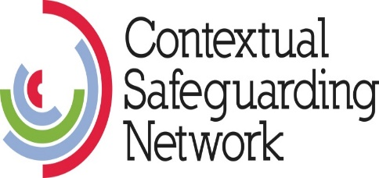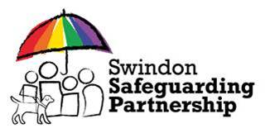

**Risk Outside The Home (ROTH)**

**Safety Mapping and Planning with Young People in Swindon**

**Resource for professionals**

**Adapted from original work - Safety Mapping Exercise created by:**

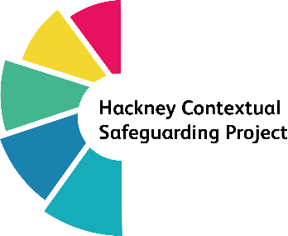

**Risk Outside The Home (ROTH) and Safety Mapping**

**Safety Planning with young people, their families and networks.**

**introduction**

For further guidance on how best to use this resource please refer to the main document [Contextual Safeguarding: Safety Mapping Exercise.](https://safeguardingpartnership.swindon.gov.uk/downloads/file/1024/swindon_safety_mapping_exercise)

[Contextual Safeguarding (CS](http://www.contextualsafeguarding.org.uk)) is an approach to safeguarding that supports practitioners to recognise and respond to the harm young people experience outside of the home.

This safety mapping exercise was originally developed by Hackney Children and Families Services to help practitioners to identify areas of risk and safety. It can be used for safety planning with children, families and networks and has been adapted for use in Swindon.

Safety mapping can be used by practitioners as part of a broader assessment of risk within local neighbourhoods or on its own with individual young people. Further details about carrying out a contextual assessment can be found on the [Contextual Safeguarding Network](https://contextualsafeguarding.org.uk/).

Young people encounter risk and safety in locations outside of the home. These experiences are crucial in shaping how young people move through their local neighbourhood and how they keep themselves safe. By carrying out safety mapping with young people, practitioners can learn and understand about where young people feel safe or at risk. This has a number of benefits:

* Offering professionals a way to understand how and why young people might choose certain routes around their local area and how this impacts them. For example, a young person might be late for appointments or school because they take longer routes to avoid risk.
* Providing a reflective space for young people to consider locations where they are safe and what to do if they encounter risk.
* Supporting professionals to consider locations of risk/safety when making decisions about young people. For example, where to place young people or what service locations may be best for them.
* If multiple safety maps are completed with several young people, they can provide an overview of risk and safety in local areas in order to support wider interventions into the local environment. If carried out over time they can support practitioners to understand the changing nature of risk in a local area.

**Best Practice**

If you have not previously completed a safety map with a young person there are some useful resources to guide you. These are available on the Contextual Safeguarding Practitioners’ Network [click here to access](https://www.csnetwork.org.uk/). If you are not already a member you will need to register. It is free.

Once registered the useful resources include:

Safety mapping exercise guide and podcast - [Safety Mapping Tool (csnetwork.org.uk)](https://www.csnetwork.org.uk/en/toolkit/assessment/safety-mapping-tool)

Safety Mapping Webinar - [Training resources and webinars (csnetwork.org.uk)](https://www.csnetwork.org.uk/en/resources/training-resources)

To access the webinar direct click on this [link](https://vimeo.com/440715858?embedded=true&source=vimeo_logo&owner=58559496) (clip lasts 16.23 minutes).

The webinar includes guidance on completing this for example, familiarising yourself with the area, building a relationship, depicting the area, map, planning and review.

When completed consider as part of the safety planning if the information should be shared with parents/carers, particularly if they have not been part of the safety mapping exercise. Please use your professional judgement to assess if this is necessary.

The completed Risk Outside The Home (ROTH) Safety Map and Planning form should be saved as an attachment on the child’s file. If a subject access request is made by a child or family member this would be redacted appropriately.

**Swindon Map**

The map below shows the Swindon Wards (with demarked boundaries in **black, bold**).

Often young people we work with can identify areas of risk and safety using these Wards and refer to them by name.

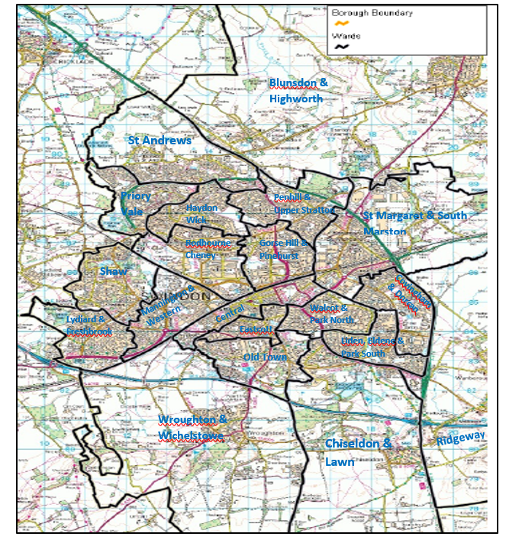

If you want to focus on a particular area of Swindon and need a more detailed map go to [Bing Maps - Directions, trip planning, traffic cameras & more](https://www.bing.com/maps/) and change the view in the top right hand corner to Ordnance Survey.

**Old Town**

**Ridgeway**

**Chiseldon & Lawn**

**Central**

**Mannington & Western**

**Shaw**

**Lydiard & Freshbrook**

**Eastcott**

**Walcot & Park North**

**Wroughton & Wichelstowe**

**Liden, Eldene & Park South**

**Covingham & Dorcan**

Screen shots are included below for information.

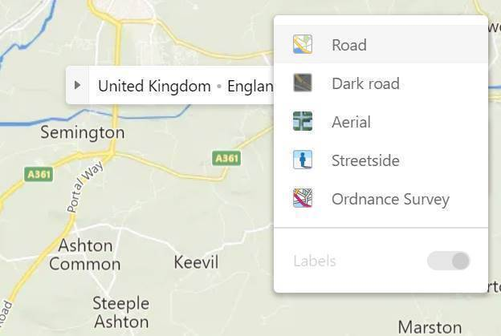

Select Ordnance Survey from the options

You can then zoom into the relevant areas required.

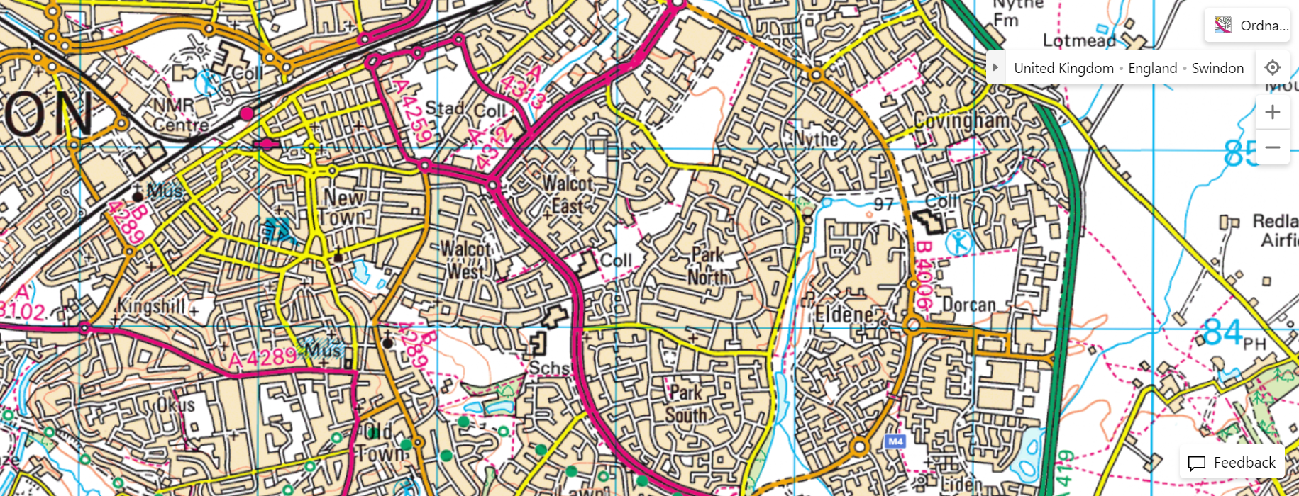

The map is simple to use as a safety planning tool and can help both you and the young person figure out safe spaces for them in the borough using a traffic light coding system.

**RED AMBER GREEN**

 I do not feel safe in this area.  I could be safe in this area.  I feel safe in this area.

**Safety mapping planning sheet**

|  |  |
| --- | --- |
|  | **Locations, people and further details** |
| **I feel safe in this area.** |  |
| **I could be safe in this area** |  |
| **I do not feel safe in this area** |  |
| **Safety Plan** |  |

**References:**

University of Bedfordshire – The International Centre, Researching Child Sexual Exploitation,

Violence and Trafficking <https://contextualsafeguarding.org.uk>

Hackney Contextual Safeguarding Project

Simone Nyarko (Consultant Social Worker) – Hackney Contextual Safeguarding Team

[Contextual safeguarding | Hackney Council](https://hackney.gov.uk/contextual-safeguarding)