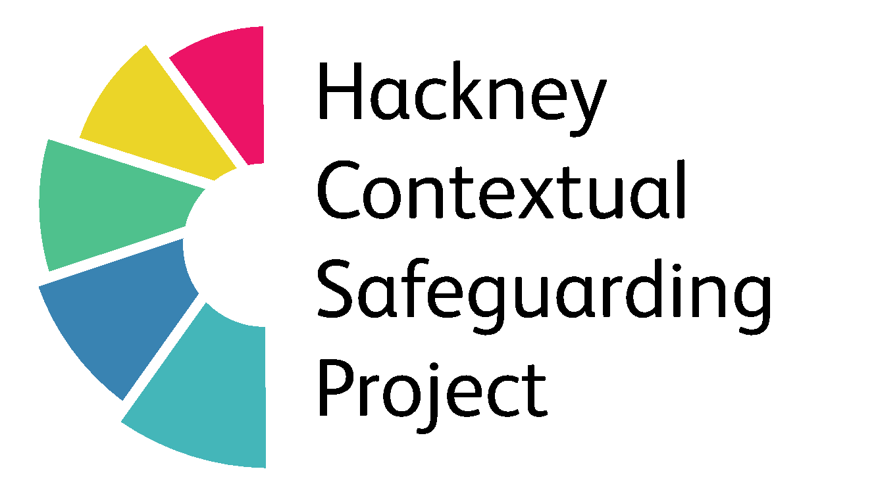
Developed by Kayleigh Broughton (2018) What’s Happening - A Tool For Children / Young People
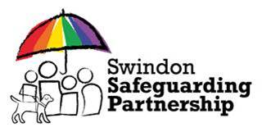
What’s Happening?
 | House and family | Friends/mutuals  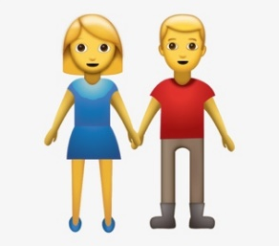 | Where you hang out  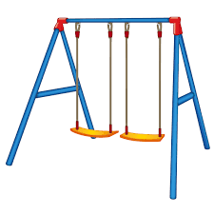 | Social Media | School/College | Anything else?
What makes you happy?
What are your worries?
What would make you feel safer?

How else can you be helped?
Scaling 1 – 5 – How Safe Do You Feel?
 | 