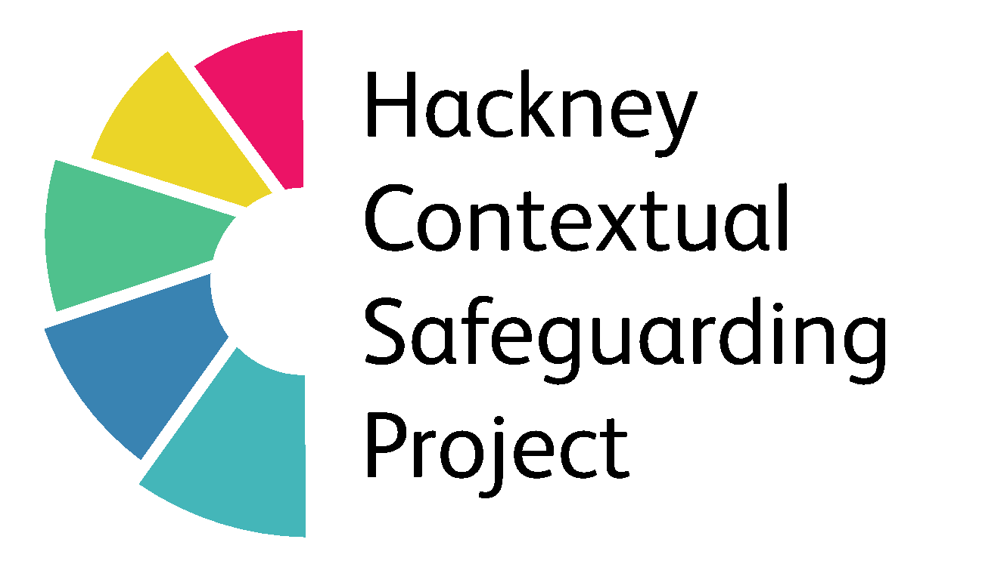
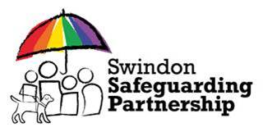
Developed by Kayleigh Broughton (2018) What’s Happening - A Tool For Parents / Carers

What’s Happening?
 | House and family | Friends/mutuals  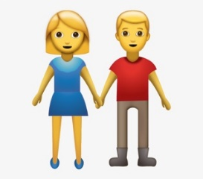 | Where you hang out  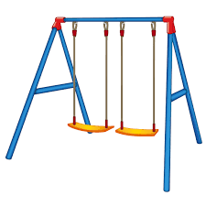 | Social Media | School/College | Anything else?
What is (name) doing at the moment that you are happy with?
What are your worries?
What might you do to help (name) to be safe?
Who/What else could help?

Scaling 1 – 5 – How Safe Do You Feel Your Child Is?
 | 