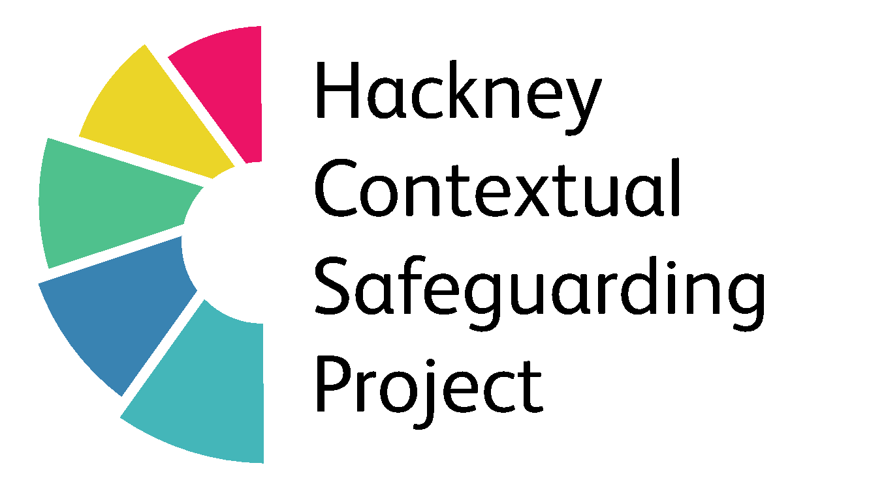

*Developed by Kayleigh Broughton (2018) What’s Happening - A Tool For Professionals*

What’s Happening?

|  |  |  |  |  |  |  |
| --- | --- | --- | --- | --- | --- | --- |
|  | **House and family**  House Emoji (U+1F3E0) | **Friends/mutuals**  Download Ai File - Holding Hands Emoji Png | Full Size PNG Download |  SeekPNG | **Where you hang out** | **Social Media** | **School/College** | **Anything else?** |
| **What is (name) doing at the moment that you are happy with?** |  |  |  |  |  |  |
| **What are your worries?** |  |  |  |  |  |  |
| **What might you do to help (name) to be safe?** |  |  |  |  |  |  |
| **Who/What else could help?** |  |  |  |  |  |  |