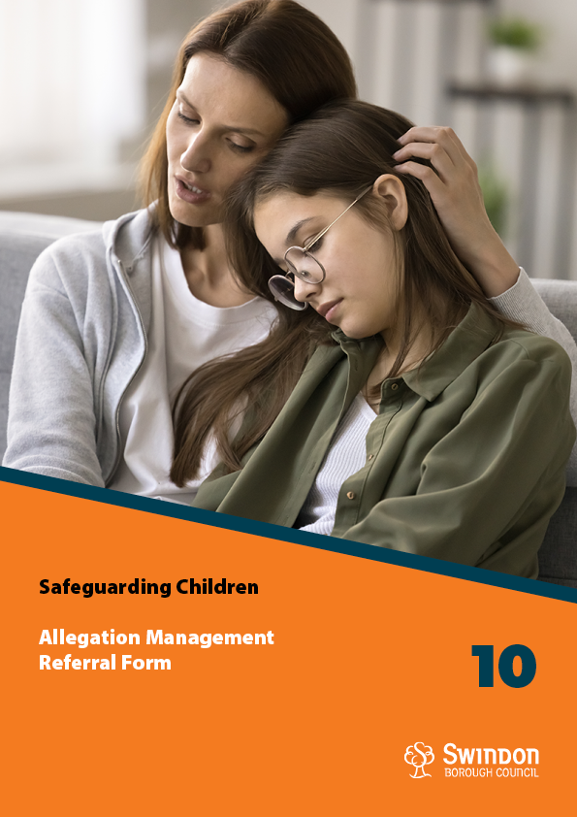

***This form should be used to make a referral regarding concerns or allegations about a member of staff. Urgent referrals should always be made by telephone, followed by completion of this form asap the same day to confirm the referral details.***

|  |
| --- |
| **Allegation Management Threshold** |
| Where an adult working with children may have:     * Behaved in a way that has harmed, or may have harmed, a child * * Possibly committed a criminal offence against, or related to, a child * Behaved towards a child or children in a way that indicates they may pose a risk of harm to children * Behaved or may have behaved in a way that indicates they may not be suitable to work with children     * Where the harm to a child may be at a Child Protection level (Significant Harm). |

|  |  |  |  |  |  |  |
| --- | --- | --- | --- | --- | --- | --- |
| **Details regarding the Person of concern / Volunteer involved in the Incident / Concern** | | | | | | |
| **First Name(s)** | | **Last Name** | | | **DoB** | |
|  | |  | | |  | |
| **Job Title / Role** | | **Place of Work** | | | **Employer** | |
| Click here to enter text. | |  | | | Select an Agency | |
| **Disability?** | | **Ethnicity** | | | **Employment Status** | |
| Select a disability. | | Select ethnicity | | | Permanent / Temporary / Agency / Volunteer | |
| **If the member of staff is agency, please provide agency details (name, main contact, contact number, email etc.)** | | | | | | |
|  | | | | | | |
| **Home Address** | | | | | | |
|  | | | | | | |
| **Are there any children living with the member of staff?** | | | | | | |
| **First name** | **Last Name** | | **DoB** | **Relationship to member of staff** | | **Tick if concerns Include these children** |
| Click here to enter text. | Click here to enter text. | | Click here to enter a date. | Click here to enter text. | |  |
| Click here to enter text. | Click here to enter text. | | Click here to enter a date. | Click here to enter text. | |  |



|  |  |  |
| --- | --- | --- |
| **Details regarding the Child involved in the Incident / Concern** | | |
| **First Name** | **Last Name** | **DoB** |
| Click here to enter text. | Click here to enter text. | Click here to enter a date. |
| **Home Address** | | |
| Click here to enter text. | | |
| **Additional needs:**  Child with a disability  Child with additional learning needs  Child looked after  Child in need | | |
| *Note: If the referral is at a Child Protection/Criminal threshold you may also be asked to complete* *a referral to Contact Swindon with additional details for the child / children.* | | |

|  |
| --- |
| **Reasons for Referral** |
| * **Date and time of incident**   Click here to enter text.   * **Description of incident / concern (location, and what happened):**   Click here to enter text.   * **Are there any injuries to the child?**   Click here to enter text.   * **Are there any witnesses to the incident/ is there any CCTV?**   Click here to enter text.   * **What is your view / assessment of this incident / concern?**   Click here to enter text.   * **What actions have you undertaken, including to safeguard the member of staff / child?**   Click here to enter text. |
| **Background regarding the member of staff** |
| * **How long have they worked in this role?**   Click here to enter text.   * **Have there been any previous concerns or allegations about them?**   Click here to enter text.   * **Do they have professional contact with children in other settings? E.g. Volunteering.**   Click here to enter text. |
| **Additional Information about the child and their parents/ carers** |
| * **What has been the impact on / response of the child?**   Click here to enter text.   * **Have parents been informed? What do they want to happen?**   Click here to enter text.   * **Provide any other information about the child you feel may be relevant*.***   Click here to enter text. |



|  |  |  |  |  |
| --- | --- | --- | --- | --- |
| **Details of person making referral:** | | | | |
| **Name** | | **Job Title / Role** | | **E-mail Address** |
| Click here to enter text. | | Click here to enter text. | | Click here to enter text. |
| **Agency Address** | | | | **Telephone Number** |
| Click here to enter text. | | | | Click here to enter text. |
| **Referrer’s Signature** |  | | **Date:** | Click here to enter a date. |

|  |
| --- |
| **Allegation Management contact details:** |
| Allegation Management Email - [LADO@swindon.gov.uk](mailto:LADO@swindon.gov.uk)  Main Contact Number – 01793 463854  Quality Assurance & Review Service, Wat Tyler, Civic Offices, Swindon SN1 2JG.  Allegation Management Referral Forms should be emailed securely toLADO@swindon.gov.uk either password protected or via Outlook 365 Encryption. If you do not have Outlook Encryption please contact us. |
| **Alternate route for urgent Child Protection concerns:** |
| If your referral is in relation to a pressing child protection issue, please alert Contact Swindon on 01793 464646 or email [contactswindon@swindon.gov.uk](mailto:contactswindon@swindon.gov.uk) in office hours. If you have a child protection concern for a child outside office hours, please make contact with our Emergency Duty Service on 01793 436699.  Alternatively, if a serious crime is disclosed immediate contact with the police may be appropriate. |

