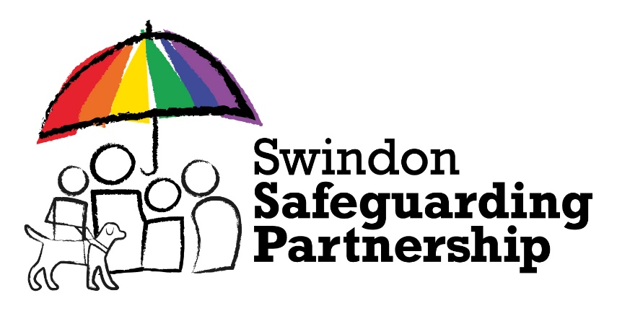

This is to certify that

[Name]

completed the

Being Professionally Curious Awareness eLearning

on

[Date]

Duration: 45 minutes

Delivered on behalf of
Swindon Safeguarding Partnership

This organisation is committed to safeguarding and promoting the welfare
of children, young people and adults and expects all staff and volunteers
to share this commitment

