Example safety plans

This plan is for:

Chosen trusted adults that will support and know about this safety plan are:

This is the plan I will follow to keep myself and other safe:

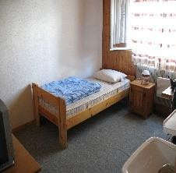
HOME

SCHOOL
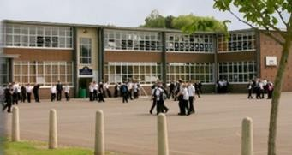

ON THE INTERNET
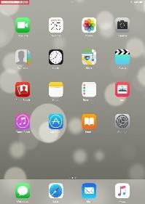

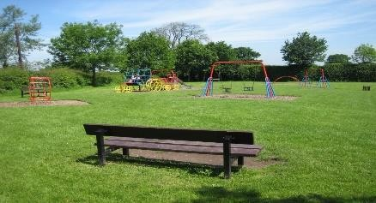
ACTIVITIES IN THE COMMUNITY

PERSONALISED SAFETY PLAN TEMPLATE WITH EXAMPLES
This plan is for:

Chosen trusted adults that will support and know about this safety plan are:

This is the plan I will follow to keep myself and other safe

HOME
Don’t play upstairs alone with brother/sister.
If the bathroom door is shut, knock on the door. If someone is there, don’t go in.

SCHOOL
Respect people’s private space when using changing rooms/toilets. Mobile phone rules must be followed.
Staff supervision

ON THE INTERNET
Don’t use the internet without an adult in the room. Don’t try and remove parental controls.
Use age appropriate sites/games. Social media use

ACTIVITIES IN THE COMMUNITY
Tell an adult where you are. Follow rules about where I can go.

