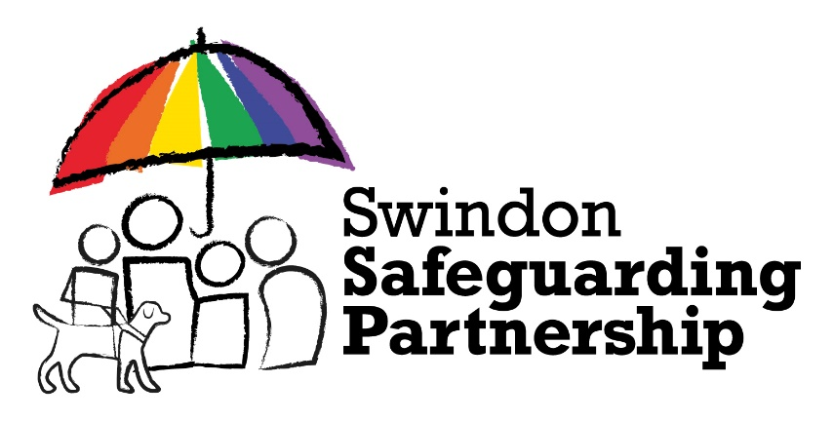

This is to certify that
(NAME)
completed

Adult Safeguarding in Swindon

On
28th January 2026

Duration: 2 hours

Delivered on behalf of
Swindon Safeguarding Partnership

This organisation is committed to safeguarding and promoting the welfare
of children, young people and adults and expects all staff and volunteers
to share this commitment

