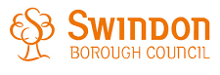
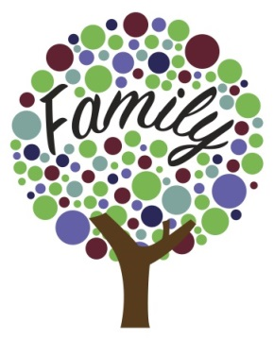
Early Help Assessment

About the Early Help Assessment
The Early Help Assessment and Plan is the common process for supporting children, young people and families with additional needs through early identification of difficulties, swift intervention and a planned, coordinated response. Early Help is a voluntary process, and agreement from the family is the key to achieving successful outcomes.

The purpose of this assessment is to work together to create an Early Help Plan for you and your family. We want to get to know your family and really understand the challenges you are facing. This will help us to work with you to find ways to work through your challenges. Building on your family's strengths, we will agree an action plan with you, to support you, which may involve other agencies. The aim is to focus on the strengths in your family and approach this with solutions in mind.

Here is what to expect from the Early Help process:
- Assessment – discuss with a professional what is going well for you as a family, as well as the challenges you are facing, and complete the Early Help Assessment together.
- Plan – agree goals and actions from the assessment at an initial Team Around the Family.
- Do – work with your Team Around the Family to make progress on the actions you identify together.
- Review – work with your Team Around the Family to review how things are going for your family, and identify what further support you need moving forward.

- Your agreement
I agree to participate in an Early Help Assessment. I understand the information I give will be used to help me and my family. I understand that this information will be shared and stored with other professionals to plan what is needed as necessary. I understand this information will be shared with other schools should my child/ren move to a different school.

Parents/Primary Carers of Child/Child’s signatures and printed names:
Primary carer 1 Signature: | Printed Name:
Primary carer 2 Signature: | Printed Name:
Young person/child signature (if appropriate): | Printed Name:
Date:
Parents will receive a copy of the completed assessment.

We will be careful with your information
The information you provide will be held on our database to help deliver the service we provide. We share and or gather information from other organisations who may be involved in working with you and your family. Information on our secure database can only be accessed by SBC employees working within Children, Families and Community Health. Please note the only reason that information will be passed on without your consent is if there is a legal requirement to do so, or if there is a risk of serious harm or threat to life. Under the Data Protection Act you can see your own personal information. If you would like to know more about this, please ask for our leaflet, ’Access to your personal information’ or contact the Data Protection Officer at Swindon Borough Council, Civic Offices, Euclid Street, Swindon SN1 2JH. Further information and a copy of our privacy notice is available at: https://www.swindon.gov.uk/directory/46/privacy_notices/category/219
If safeguarding concerns were to be identified, we would have a duty to complete a safeguarding referral to Contact Swindon contactswindon@swindon.gov.uk 01793 46 46 46

- Your agreement – Practitioners:
I agree to help you complete the Early Help Assessment and make plans with you to get things working well. This means I will:
- Help you to record what is working well and what could be better
- Liaise with agencies and other professionals involved in your life. E.g. GP, Health Visitor, Housing Advisor if needed
- Explain and organise a meeting called a ‘Team Around the Family’ meeting if needed
- Provide support from my agency
- Request specialist support if needed

Professional completing Assessment signature and printed name:
Signature: | Printed Name:
Agency: | Contact Number:
Email: | Date:

