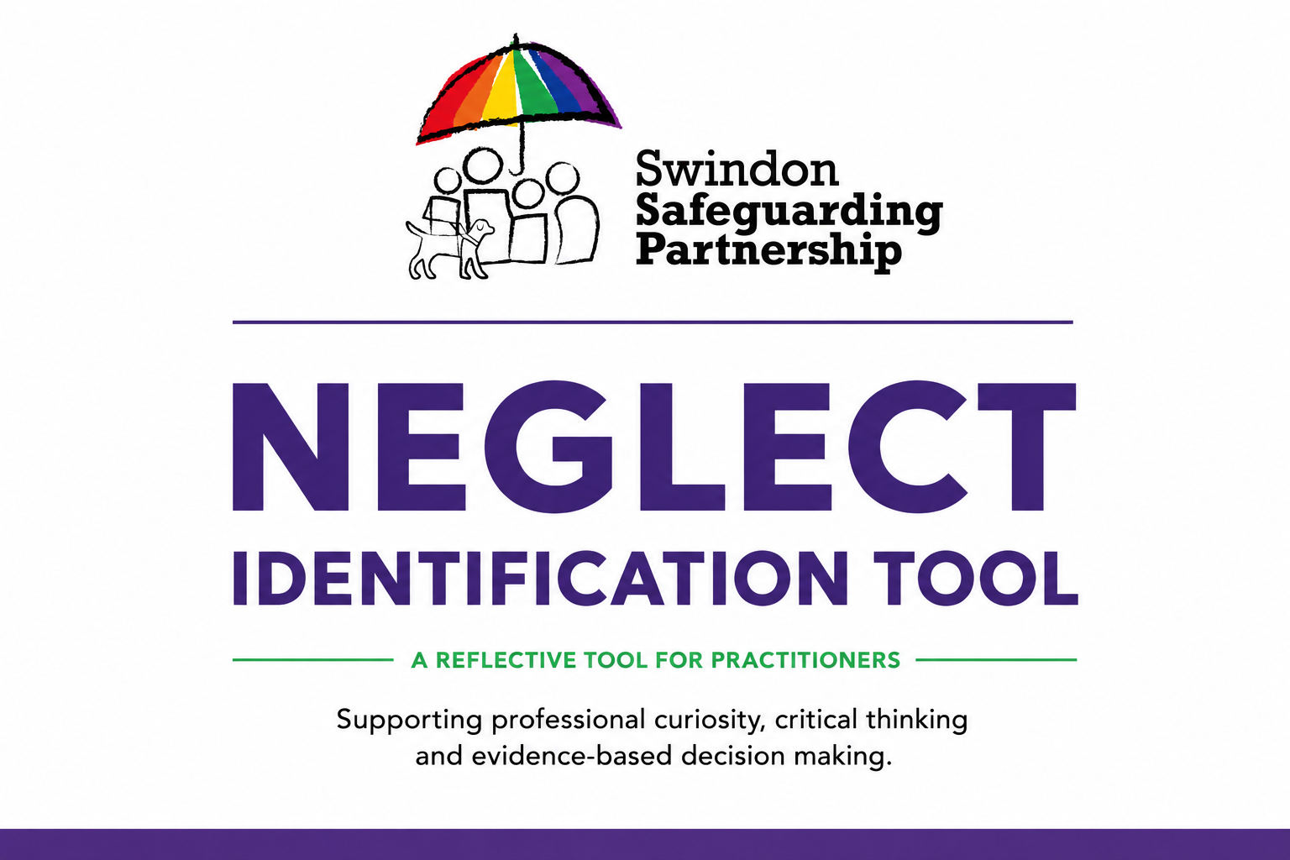
Use the Neglect Identification Tool during supervision, case discussions or to aide reflective practice when there are concerns that a child may be experiencing neglect. It is designed to support professional curiosity, critical thinking and evidence-based decision making by helping practitioners consider the child's lived experience, the impact of neglect, parental capacity to change, and the effectiveness of current intervention.

Work through each section using the information available from direct work with the child, family, partner agencies and case records. Focus on the quality of care the child experiences day-to-day, identify strengths alongside concerns, and record evidence rather than assumptions. Use this tool to challenge drift, inform risk assessment, identify any gaps in knowledge, and agree clear actions to improve outcomes for the child.

This tool should complement, not replace, professional judgement, statutory assessments and safeguarding procedures.



Understanding the Child/Children’s Experience
What is the child/children’s day-to-day life like? Think about food, cleanliness, affection, stimulation, and safety.
🍽️ Physical Neglect: Not having enough food, clean clothes, a safe place to live, or help to stay clean and healthy.

What signs show that the child/children are experiencing physical neglect?

❤️ Emotional Neglect: Not enough love, attention, or emotional support.

What signs show emotional neglect?

🩺 Medical Neglect: Not supported with health or dental care.

What signs show medical neglect?

📚 Educational Neglect: Not going to school or being supported to learn.

What signs show educational neglect?

🛟 Supervision/Safety Neglect: Not being watched properly or being left with unsafe adults.

What signs show poor supervision or safety risks?

🥗 Nutritional Neglect: Not providing enough food or the right nutrients for healthy growth.

What signs show nutritional neglect?

😊/😞 What does a good day look like for the child/children? What does a bad day look like?

🗣 Child’s Voice

What does the child/children say, show, or communicate about how they feel?

How is the child/children’s voice evident in case notes? What does it tell us about their experiences and needs?

📈 Development

How has neglect affected the child’s growth, learning, or behaviour? What does this look like for the child/children?

👨‍👩‍👧 Parent/Carer Capacity

What is the evidence that the parents/carers lack understanding of, or are unable to consistently meet, the child’s needs?

What is the evidence that parents/carers are making changes that improve the child’s life?

Are they addressing risks like unsafe home conditions?

Is the child acting as a young carer?

⚠️ History and Risk

What is the long-term impact of concerns for the child/children?

Is there a chronology showing the child/children’s history?

Is there “start-again syndrome” where previous patterns have been ignored?

🧭 Reflective Practice

Have I allowed the case to drift? Has enough been done?

How might culture, race, disability, or beliefs affect the child’s experience?

Are my own biases affecting my decisions?

What evidence supports the actions being taken?

Is urgent action needed to keep the child safe?

Do I need to use escalation to challenge decision making?

To support effective assessment and decision-making, this tool should be included with all referrals to Children’s Services where there are identified concerns regarding neglect contactchildrenandfamilies@swindon.gov.uk.
Appendix 1: Domains of Neglect
- Physical Neglect: Failure to provide adequate food, clothing, shelter, or hygiene. Examples include severe lack of cleanliness, inappropriate clothing for the weather, or hazardous living conditions.
- Emotional/Psychological Neglect: Failure to meet a child’s basic emotional needs, such as affection, interaction, and nurturing. This includes indifference, social isolation, or exposing a child to intense, harmful emotional environments.
- Medical Neglect: Failure to provide necessary health care, including dental care, or neglecting to follow medical advice for treating or preventing illness.
- Educational Neglect: Failure to ensure a child receives an education, such as allowing chronic absenteeism, not enrolling a child in school, or failing to address special educational needs.
- Supervision and Safety Neglect: Failure to provide proper supervision to keep a child safe, resulting in exposure to environmental dangers, neglectful abandonment, or leaving children with unsafe caregivers.
- Nutritional Neglect: The failure to provide sufficient food or an appropriate, balanced diet to ensure the child's healthy physical and brain development.

