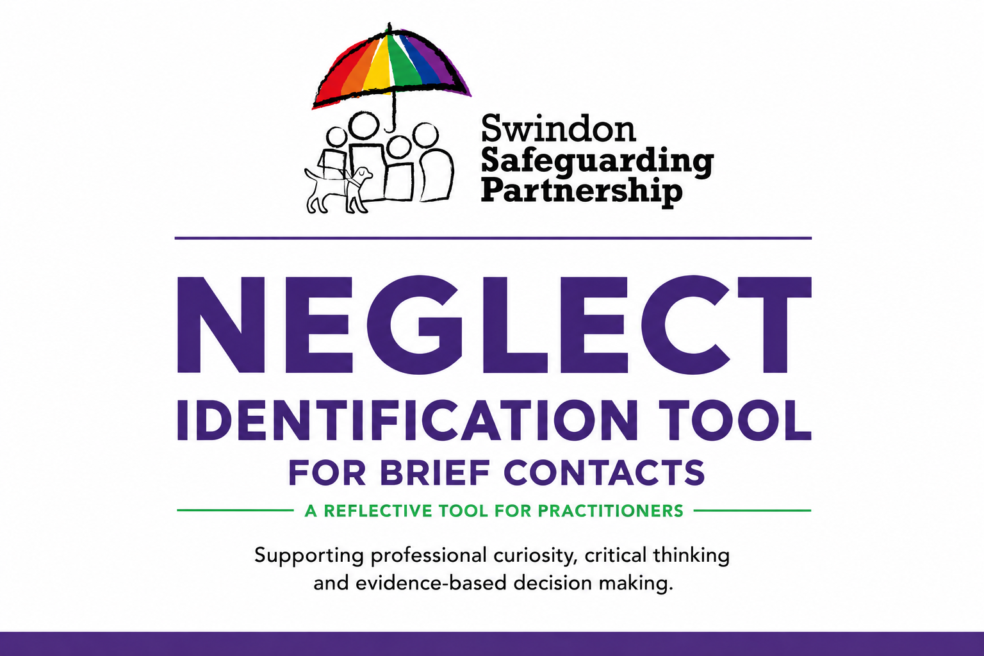

This Neglect Identification Tool is designed for practitioners who have had brief or limited contact with a child and have concerns about the quality of care they are experiencing. It supports professional curiosity, critical thinking, and evidence-informed decision making by helping practitioners identify possible indicators of neglect, consider the child's lived experience, and determine whether further assessment, information sharing, or intervention is required. The tool is intended to support, not replace, professional judgement.


Understanding the Child/Children’s Experience
What is the child/children’s day-to-day life like?
Think about food, cleanliness, affection, stimulation, and safety.
🍽️ Physical Neglect: Not having enough food, clean clothes, a safe place to live, or help to stay clean and healthy.
What signs show that the child/children are experiencing physical neglect?
❤️ Emotional Neglect: Not enough love, attention, or emotional support.
What signs show emotional neglect?
🩺 Medical Neglect: Not supported with health or dental care.
What signs show medical neglect?
📚 Educational Neglect: Not going to school or being supported to learn.
What signs show educational neglect?
🛟 Supervision/Safety Neglect: Not being watched properly or being left with unsafe adults.
What signs show poor supervision or safety risks?
🥗 Nutritional Neglect: Not providing enough food or the right nutrients for healthy growth.
What signs show inadequate nutrition?
Presentation of Parents/Carers
How are the parents/carers responding to the child?

🗣 Child’s Voice
What does the child/children say, show, or communicate about how they feel?
How is the child/children’s voice evident in case notes? What does it tell us about their experiences and needs?

Include the completed tool with any onward referrals made for the child/ren to Children’s Services contactchildrenandfamilies@swindon.gov.uk
Appendix 1: Domains of Neglect
- Physical Neglect: Failure to provide adequate food, clothing, shelter, or hygiene. Examples include severe lack of cleanliness, inappropriate clothing for the weather, or hazardous living conditions.
- Emotional/Psychological Neglect: Failure to meet a child’s basic emotional needs, such as affection, interaction, and nurturing. This includes indifference, social isolation, or exposing a child to intense, harmful emotional environments.
- Medical Neglect: Failure to provide necessary health care, including dental care, or neglecting to follow medical advice for treating or preventing illness.
- Educational Neglect: Failure to ensure a child receives an education, such as allowing chronic absenteeism, not enrolling a child in school, or failing to address special educational needs.
- Supervision and Safety Neglect: Failure to provide proper supervision to keep a child safe, resulting in exposure to environmental dangers, neglectful abandonment, or leaving children with unsafe caregivers.
- Nutritional Neglect: The failure to provide sufficient food or an appropriate, balanced diet to ensure the child's healthy physical and brain development.

