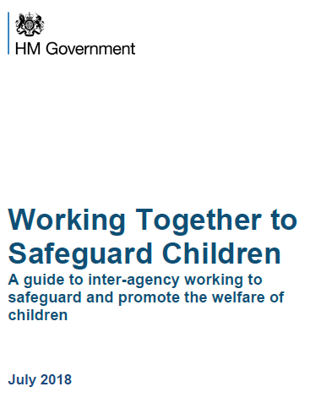 | Safeguarding Children  The Management of Allegations against staff or volunteers who work with children  Allegation Management Referral Form

Allegation Management Referral Form

This form should be used to make a referral regarding concerns or allegations about a member of staff. Urgent referrals should always be made by telephone, followed by completion of this form asap the same day to confirm the referral details.

Details regarding the Member of Staff / Volunteer involved in the Incident / Concern
Last Name |  | First Name |  |  | DoB
Click here to enter text. |  | Click here to enter text. |  |  | Click here to enter a date.
Job Title / Role |  | Place of Work |  |  | Employer
Click here to enter text. |  | Click here to enter text. |  |  | Select an Agency
Disability? |  | Ethnicity |  |  | Employment Status
Select a disability. |  | Select ethnicity |  |  | Permanent / Temporary / Agency / Volunteer
Home Address
Click here to enter text.
Are there any children living with the member of staff?
Last Name | First name |  | DoB | Relationship to member of staff |  | Tick if concerns Include these children
Click here to enter text. | Click here to enter text. |  | Click here to enter a date. | Click here to enter text. |  | ☐
Click here to enter text. | Click here to enter text. |  | Click here to enter a date. | Click here to enter text. |  | ☐

Details regarding the Child involved in the Incident / Concern
Last Name | First Name | DoB
Click here to enter text. | Click here to enter text. | Click here to enter a date.
Home Address
Click here to enter text.
Note: If the referral is at a Child Protection/Criminal threshold you may also be asked to complete an RF1 with additional details for the child / children.

Reasons for Referral
- Description of incident / concern (Date, time, location, and what happened):
Click here to enter text.
- Are there any injuries to the child?
Click here to enter text.
- Are there any witnesses to the incident?
Click here to enter text.
- What is your view / assessment of this incident / concern?
Click here to enter text.
- What actions have you undertaken, including to safeguard the member of staff / child?
Click here to enter text.
Background regarding the member of staff
- How long have they worked in this role?
Click here to enter text.
- Have there been any previous concerns or allegations about them?
Click here to enter text.
- Do they have professional contact with children in other settings? E.g. Volunteering.
Click here to enter text.
Additional Information about the child and their carers
- What has been the impact on / response of the child?
Click here to enter text.
- Have parents been informed? What do they want to happen?
Click here to enter text.
- Provide any other information about the child you feel may be relevant.
Click here to enter text.

Details of person making referral:
Name |  | Job Title / Role |  | E-mail Address
Click here to enter text. |  | Click here to enter text. |  | Click here to enter text.
Agency Address |  |  |  | Telephone Number
Click here to enter text. |  |  |  | Click here to enter text.
Referrer’s Signature |  |  | Date: | Click here to enter a date.

Next Steps:
This Referral Form should now be emailed securely to LADO@swindon.gov.uk . For support with this please call 01793 463854

Allegation Management contact details:
Allegation Management Team - 01793 463854
Jon Goddard (LADO) - 07392 103019 (Monday – Wednesday, 9am – 5pm)
Rachel Hull (LADO) – 07824081177 (Thursday – Friday, 9am – 5pm)
Quality Assurance & Review Service, 1st Floor, Clarence House, Euclid Street, Swindon SN1 2SG

Alternate route for urgent Child Protection concerns:
If your referral is in relation to a pressing child protection issue, please alert the MASH Team on 01793 466903. The team can be contacted Monday to Thursday 8.30am-4.40pm, and Friday 8.30am-4pm. If you have a child protection concern for a child outside of these hours, please make contact with our Emergency Duty Service on 01793 436699.

Date updated: 28.10.19

Title picture reproduced from Working Together to Safeguard Children 2018 – HM Government @Crown Copyright 2018

