Swindon Safeguarding Partnership
Multi-Agency Child Protection Conference Report
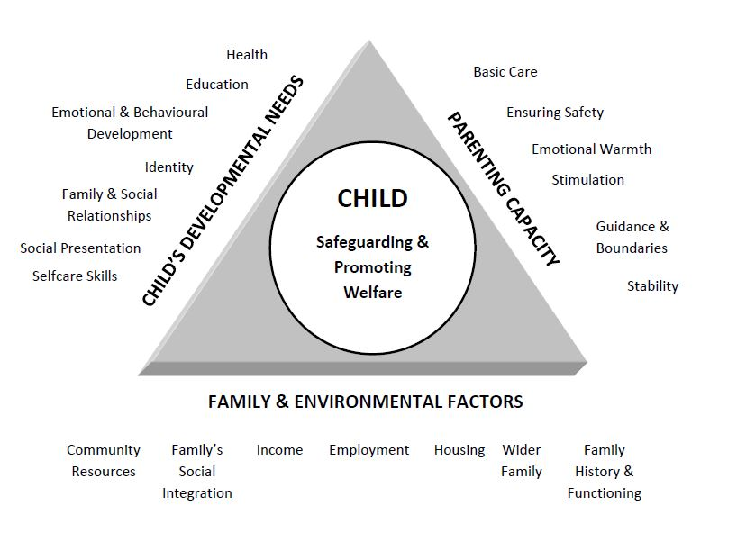

Agency’s Name |  | Professional’s Role / Job Title
Professional’s Name |  | Professional’s e-mail address
Professional’s Address |  | Professional’s Contact Number
Date of Conference

- Child(ren)’s Details
Forename | Surname | DOB | Address | Ethnicity | Disability or  Special Need | School or Nursery
- Details of Parents, Carers or Significant Family or Household Members
Forename | Surname | DOB | Address | Ethnicity | Disability or  Special Need | Relationship To Child | Parental Responsibility?

- Overview of your agency’s involvement with child/family
How long have you been involved with the child/family?
- What are you worried about?
Include what factors you consider to pose risk of significant harm or increase the risk of harm to the child/children?
- Historical Concerns?
Information about previous concerns or factors from the parent’s own childhoods which could increase the risk.
- What’s working well?
Safety factors which you believe reduce the risks of harm to the child/children or help to ensure safety. Features of family life and parenting that have a positive effect on the children’s lives.
- What would reduce our concerns?
What do you believe will make this child or children safe?
What should professionals do?
What should the Family do?
- What do you believe to be the likely outcome for the child(ren) if their current situation continues?

- What areas of risk or concern can your agency help the parents/carers to resolve?
Briefly describe what contribution your service can make to the child(ren)’s plan.
- What are the views of the parents/carers and/or the child(ren)/young person on this report?

- For review meetings, what difference do the child and parents think the plan has made to their lives and the difficulties they were facing?

Author’s Name |  |  |  | Designation
Signature |  |  |  | Date
Manager’s Name |  |  |  | Designation
Signature if appropriate |  |  |  | Date
Has this report been shared with parents/carers? |  | Y | N | Has this report been shared with the child(ren)/young person? |  | Y | N
If yes, date: |  |  |  | If yes, date:
If not, state reason why |  |  |  | If not, state reason why

It is the responsibility of all agencies who have participated in as child protection enquiry or who have relevant information to make this available to the conference in the form of a legible and signed report. The report should be provided to parents at least 2 working days in advance of initial conferences and 5 working days before review conferences.

