Safeguarding Guidance to health professional conducting non-face to face Health Assessments or Reviews

Introduction:
The COVID-19 crisis has brought about considerable changes to the way we conduct both our professional and personal lives. This has led to innovation in the use of video and telephone consultation but has also led to new safeguarding concerns and risks which may be harder to detect during a non-face to face assessment. This adds a new cohort of health and safeguarding concerns to the likelihood of deteriorating health in those people who are considered to be ‘vulnerable’ because of COVID19 and others for whom there would not have been any health or safeguarding concerns had it not been for COVID.
Under these circumstances it is particularly important to safeguard the whole community we work with and particularly those who because of their health or social care needs are at risk of abuse; children and families known to be vulnerable, those who become vulnerable and adults with care and support needs.
It is becoming clear that some of these groups are more vulnerable to abuse and neglect, as others may seek to exploit disadvantages due to age, disability, mental or physical impairment or illness.
While there is a degree of uncertainty about what has been referred to as the ‘new normal’ it is clear that the impact of COVID on how we conduct our daily health business will be with us for some time to come. From an NHS point of view in responding to COVID there are four key phases.

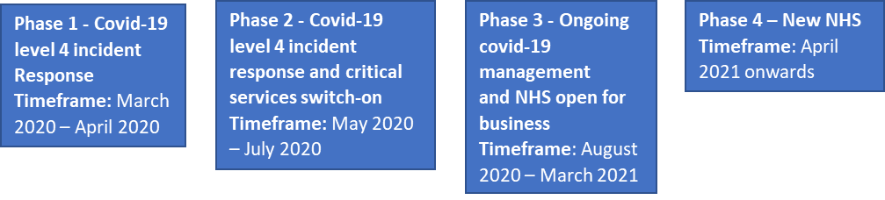
This guidance is written with these four phases in mind as it draws the practitioners’ attention to considering the initial impact on our communities in all our clinical activity and the areas to think about whilst conducting our clinical work virtually.
About this guidance
This guidance is written to support health practitioners in conducting their routine professional duties when relying on non- face to face health assessments or reviews (NFFHAR). This guidance should be used as an adjunct to existing statutory or professional body guidance and is not intended to replace any statutory guidance and clinical procedures.
What is the status of this guidance?
This advisory guidance is written by Designated Professionals for safeguarding children and adults, Named GPs for safeguarding and Designated Professionals for Children Looked After based within NHS Bath and North East Somerset, Swindon and Wiltshire Clinical Commissioning Group (BSWCCG). Other colleagues within similar roles outside of BSWCCG are welcome to use or adapt this guidance to suit their specific service need.

Who is this guidance for?
This guidance is aimed at any health professional or support staff working within a health care setting who carries out a NFFHAR currently or plans to do so as part of a change in the clinical practice and interface they have with patients.
Purpose:
The purpose of this guidance is to ensure all practitioners are aware of the associated safeguarding issues when conducting NFFHAR, highlight the skills required and provide practical tips and techniques to use when conducting NFFHAR.
Link to other guidance
Practitioners using this guidance should also refer to their local safeguarding procedures, and professional body advice where necessary.
RCGP Principles of safe video consulting in general practice during COVID-19
https://www.england.nhs.uk/coronavirus/wp-content/uploads/sites/52/2020/03/C0479-principles-of-safe-video-consulting-in-general-practice-updated-29-may.pdf
Definition of a Non- Face to Face Health Assessment or Review (NFFHAR)
For the purpose of this guidance NFFHAR refers to;
- Assessments conducted virtually by a web-based platform allowing the practitioner to see the patient and their local environment. The practitioner may be able to direct them to show parts of the body for clinical assessment as far as it is possible or areas of their local environment.
- Assessments conducted where both the patient and carer are included in the assessment.
- Assessments where only the carer is included
- All telephone assessments
Before conducting a NFFHAR
Before conducting the NFFHAR consider if this is the most appropriate method of assessment or review and whether a face to face contact within a health setting or the patient’s own home is more appropriate, in either case the decision to conduct or not conduct a NFFHAR should be recorded within the patient record. The decision to offer a video consultation should be part of the wider system of triage and management offered and should be based on clinical judgement. There is no need to use video when an online consultation or telephone call is sufficient. Be aware that patients or their relatives may record the video consultation. (RCGP guidance- link above)
Conducting a NFFHAR
Preparation:
Technical – there are a range of platforms available for conducting NFFHAR, those supported by the NHS are
NHS Digital have licenced agreements with AccuRx and AttendAnywhere which should be the preferred platform. If the provider has already established an alternative platform that would fulfil IG stipulations that would be permissible.
- AccuRx https://www.accurx.com/covid-19
- AttendAnywhere https://england.nhs.attendanywhere.com/resourcecentre/Content/Home.htm
Where these are not available, during COVID-19 the NHSX Information Governance team advises it is acceptable to use free video conferencing tools such as Skype, WhatsApp and/or Facetime, if there is no practical alternative, but this should be a temporary measure until a nationally assured product can be procured. Explicitly check with the supplier if the product audio and/or video records and stores the consultation as a default and turn this setting off
Before conducting NFFHAR ensure the equipment and platforms – by testing in advance and being fully aware of the ‘platform’ of choice functions and limitations. Allow sufficient time to conduct the assessment and allow time to go over if required and for any questions/queries from the person being assessed or their carer.
Professional- the practitioner should have all the relevant patient/client health information to hand whilst conducting the NFFHAR, this includes historic safeguarding concerns/risks (if available at the time) which may be ongoing or re-emerge as an issue. Depending on which pathway the virtual assessment will follow at the outset (but could change during the assessment), think in advance what the assessment questions will be - if there are confirmed or possible safeguarding issues be clear on the most important questions and areas to focus on. A few well thought out questions are better than numerous ill prepared or vague ones.
If the medical notes are in electronic form, often a second monitor can be useful for the consultation but these may not often be available. The practitioner needs to be conducting the clinic from an appropriate work environment and should maintain all professional standards as per their governing body.
It will be important where possible to co-ordinate calls to the child, family or adult with other professionals working with them to avoid multiple calls or duplication
Use of technology to disguise backgrounds- if the professional is working from home consideration should be given to how you appear including your background, the same standards of dress would apply as if you were seeing the individual in the normal face to face way. On the platforms available to conduct assessments it is possible to change the background to a neutral one or hide the home background from view. Its important to consider if your chosen background could be deemed inappropriate for the person you are assessing.
Ensure as much as possible that you won’t be disturbed during the assessment depending on your room availability.
Patient/client – who is the patient/client to be assessed? And what should be included? Refer to flow chart 1 below. to identify the type of approach required.
All patients/clients should be prepared in advance of assessment as much as possible on what to expect when being assessed virtually. Consent of the patient is implied by them accepting the invitation and entering the virtual assessment
For people with communication difficulties (e.g. Learning Difficulties /Autism/Hearing impairment or cognitive difficulties) consider any practical solutions for overcoming these including any specialists who need to be involved to assist the virtual assessment. This includes considering if an interpreter may be needed for patients for whom English is not their first language.
- Clarify the person to be assessed is the person you are expecting to assess, ask them to provide their name address and date of birth, if they are able to. If you have a suspicion that this is not the person who needs to be assessed, then also request visible ID, preferably photographic.
- Let them know approximately how long the assessment will take
- Ask who else is in the room whilst the assessment is being conducted
- Prior to conducting any conversation around domestic abuse, ask the patient if it is safe to talk, saying a simple “yes” or “no” will do. If it isn’t then ask for a suggested safe time to call back. Be aware that situations change quickly and that risk is dynamic. (refer to IRIS guidance see safeguarding below)
- Ask for people who should not be involved to leave the room and have this confirmed.
- If the person being assessed has access to headphones or earbuds they should be suggested to ensure others who are in the room will not hear the assessment questions.
- Give a confidentiality statement before commencing the assessment particularly where any disclosure may be made and the circumstances under which that confidence will be broken.
- Seek their consent to continue with the assessment and if you intend to take photoshoots or record the assessment seek additional consent to do so.
- If you do not need to take photoshoots or take a recording of the assessment let the individual know that no recordings will be taken and also request that they do not record the assessment either.
- Inform them of how information provided will be stored or shared with other health professionals or other agencies.
Pathway 1. Patient / client known – no current health concerns – This may be the first contact with the individual following COVID restrictions or the first time this patient is being assessed virtually. In addition to the purpose of the health assessment the clinician should be mindful of wider health and social impact brought about by COVID restrictions and incorporate questions related to their experiences of COVID restrictions e.g. starting the assessment with general welfare questions
We know COVID has affected people in a variety of ways depending on their home, work or education routines, some people have struggled to cope with these changes recognise this may be the case for the individual you are assessing
Possible questions to ask
How have you been during the COVID restrictions?
Have changes to your routines meant you are worrying more about your health or that of others?
Have you managed to keep in touch with loved ones?
Have you been able to occupy yourself in a positive way and been able to get out to exercise or walk?
Have you been able to get most or all the things you would normally get for yourself or others e.g. food and other household goods?
Some people have found themselves eating more, drinking alcohol more, smoking more…in their relationships have been bickering or arguing more. Have you found yourself doing something more often and are worried about it?
Pathway 2. Patient / client known – current health concerns or complex health concerns (e.g. cognitive impairment - learning disabilities /Chronic physical health conditions that means the person has care and support needs) – following a review of the health record consider questions directly related to the likely impact of COVID on the health or social wellbeing of the individual. Is a virtual assessment the most appropriate method to assess or review their care?
Pathway 3. Patient / client - completely unknown
You may have very limited information regarding the individual you are about to assess, as with the pathways above specific questions relating to COVID experiences are important along with broader health and social wellbeing questions.
All the above patients / clients should be asked standard questions relating to any other services involved including Children’s Social Care, Adult Social care or Adult Safeguarding at the start of the assessment and the remainder of the assessment adjusted accordingly.
Safeguarding specific
Pathway 4.
- Safeguarding issue identified during pathways 1-3
- Patient / client- no health concerns but known social care vulnerabilities or safeguarding issues
- Patient / client – health concerns plus known social care vulnerabilities or safeguarding issues
For the Pathway 4 individuals, the assessment must focus on the safeguarding issues identified or those being followed up, along with any health conditions present.
If a virtual method is the only feasible option for conducting a NFFHAR of known social care vulnerabilities or safeguarding issues consider the following, and plan for a follow up face to face assessment when circumstances allow.
What to look for:
Practitioners should be mindful of the limitations of virtual assessments in terms of:
- what and who you can see and the wider home environment.
- clarity on who is in the house at the time and whether there are individuals in the room who would not normally be or who the individual being assessed would not normally want to be in the room but unable to ask them to leave due to coercion and controlling behaviours,
- or risk of other forms of abuse.
- Identifying physical clinical features which may be indicative of abuse
Is the virtual assessment the most appropriate method or should a face to face clinic appointment be arranged or a home visit conducted instead?
Presentation of the individual and their environment:
Does the person appear calm or are they unduly anxious, or anxious when certain questions or areas are asked about?
Do they look as if they are looking to another person you can’t see before answering, or hesitating for a long period before answering?
Are they refusing to answer some questions or particularly vague in their answers?
If you are assessing or reviewing a child, how do they appear with the parent or carer; are they settled, showing a positive/appropriate interaction taking into account how any health issue may affect the child during the assessment e.g. their willingness to co-operate, being miserable because of illness? Are they unduly distressed?
From what you can see within the room where the patient is, are there any worrying signs e.g. evidence of neglect, physical damage likely to be caused by another person who may be violent?
Are there any worrying background noises or conversations suggestive of coercion?
If this was a home visit are there rooms you would want to see such are bedrooms? If you have asked the individual to show you these areas virtually has this been refused?
If there are known concerns regarding neglect or self-neglect as much of the home as possible should be made visible to the practitioner.
Does the child’s language, body language or level of engagement change during the assessment? Consider if this means someone has entered the room.
What to ask about and how to ask.
In addition to the known existing or suspected concerns, it will be important to consider the impact of the current situation on the child or adult and their caregivers, including; environment, overcrowding, dealing with stress, access to essential items, financial implications strained relationships, reduced support network, child not being seen in school, the adult not being able to keep to their usual social routine any difficulty in accessing services. It is important that conversations start with this recognition and attempts are made to identify issues directly related to the COVID restrictions.
- The individual and their safety –
During COVID have you been worried about your or anyone else’s safety?
Has anything happened to you during this period that has made you feel unsafe or caused you harm?
Has there been a time during COVID where you felt so unsafe you wanted to call someone but didn’t?
- About a child under their care-
Have you been worried about a child or children in your care during COVID?
What have been the things you have been most concerned about for your child or children?
Does your child or children understand as best they can what is going on because of COVID?
Ask the child about their day to facilitate their engagement in the NFFHAR
- About an adult under their care-
Does the adult being cared for have capacity to understand what is happening due to COVID?
Given their capacity do they understand why their routines and contact with other people has changed?
Consider how the patients/clients can have accessible information to promote capacity/autonomy and choice whilst being assessed.
Is the carer managing with the new circumstances and have they been able to make adjustments to minimise disruption to the individual’s routine?
Consider the individual’s potential loss of autonomy and independence and how this is managed by the carer.
- Relationships within the home and wider family network –
We know the COVID restrictions have prevented people from accessing the support they would normally receive from friends, family and services involved with them, is this something that has happened to you?
Have the COVID restrictions increased the tensions in relationships within the household to the point that they are unmanageable by the normal strategies of coping?
Have tensions created an atmosphere where you or others around you feel unsafe?
Do you have money or employment concerns that are causing tensions in the home or making them worse?

- The abuse/ safeguarding concern-
The known or suspected safeguarding concerns must be specifically explored during the NFFHAR in the context of the impact on the health and the role of the health professional. The detail of the safeguarding concern is key to the questions to be asked regarding the concern.
It might be helpful to ask a scale question to determine if the concern has got worse has not changed or improvements are being made.
e.g. Neglect- Possible scale question- on a scale of 0-10 where 10 is you able to support the individual you are caring for with everything they need (food, hygiene, shelter emotional warmth etc) and things are going well, and 0 is; as much as you want to provide all these things for them, you are unable to do so, where are you now?
Concerns regarding domestic abuse- if it becomes clear that here are concerns regarding domestic abuse ask if the patient is alone to ensure that the perpetrator is not in the same room.
Be aware that the perpetrator may be in the house or enter the house and ask the patient to terminate the call if the perpetrator comes into the room. Ask if the patient feels safe and if there is any immediate danger. Always advise calling 999 if there is any immediate danger. If the patient is unable to do this, offer to do this instead. Consider use of ‘closed’ questions when asking about safety – questions with ‘yes/no’ answers may help your patient share that they are being harmed, even if they cannot talk freely.
The practitioner should follow the suggested guidance for asking routine inquiry questions e.g. the 5 R’s link below.
(https://pdfhost.io/v/EaI78LLgC_IRISi_COVID19_Doc_and_info_sheets.pdf ).
The practitioner may also need to complete the standard DASH risk assessment tool to support an onward referral to domestic abuse support services or MARAC if appropriately trained and competent to do so.

- Their health –
Concerns regarding either the carer’s health (physical or mental) or the health of the child or adult being cared for (physical or mental) health will impact on the ability of the carer to safeguard and provide the care needed.
Under COVID- access to health services has been restricted and the public have been wary about seeking health advice at a health setting due to their own fears about COVID or they may have been unable to obtain normal medications for their condition.
If there are physical elements the assessment requires e.g. the persons height and weight, if this cannot be reliably provided by the individual or their carer a face to face follow-up should be arranged.
Possible questions;
Has your health deteriorated since the onset of COVID restrictions?
In what way has COVID affected your mental health … your physical health?
Have you needed to call 111 or emergency services due to concerns about your health? OR about concerns for a child or adult if you are their carer?
Acting on concerns-
If you have concerns; safeguarding or otherwise following the health assessment you need to act on these concerns – this may mean to follow your own agency escalation and reporting to a senior clinician or safeguarding lead or making a safeguarding referral directly following your usual procedures.

Failure to make contact-
Failure to make contact with the individual when scheduled should be considered under the professionals organisation ‘DNA’ or ‘was not brought’ policy, with due consideration for technical issues, noting that this may be an excuse rather than a reason.
Recording of the NFFHAR-
It should be clearly recorded within the record whether the interaction that the interaction was NFF including how e.g. via telephone, or via video call. The information should be recorded succinctly, including who was present, who was spoken to, whether the child or adult reliant on a carer was ‘seen alone’ (in a separate room via video call) along with the detail of the assessment and plan.
Signposting to other services:
Practitioners should familiarise themselves with the local authority resilience hubs and CCG health co-ordination hubs to support children, families and adults in accessing the essentials they need including medications.
BSW community hub contact – e-mail
Bswccg.swindoncommunityresponsehub@nhs.net
bsccg.banescommunityresponsehub@nhs.net
wccg.wiltshirecommunityresponsehub@nhs.net

Professional competencies training and supervision to support conducting NFFHAR:
- Use of technology – its important to understand the functions and limitations of the technology used by the professional and that of the patient/client

- Communication skills over a virtual medium- communication over a virtual method is new to many health professionals and their service users, - it may feel alien, artificial or intrusive (we are expecting the service users to expose parts of their world we would not normally see). The professional is also potentially exposing parts of their world to service users in a way that would not normally occur, e.g. if working from home where children or other adults or pets intrude on the assessment when conducted.

- Building rapport – this is key to a successful working partnership with patient/client/service users, building rapport over a virtual means will no doubt be difficult and may feel strange however there are core things that can still be done which are key to building rapport

- Maintain Eye Contact. Maintaining eye contact communicates care and compassion though this is difficult if using a videocamera rather than a laptop or smartphone ...
- Show empathy (the ability to understand the patient's situation, perspective and feelings. ...)
- Open Communication. ...
- Make it Personal. ...
- Active Listening. ...
- Practise Mirroring. ...
- Keep Your Word.

- The use of appreciative inquiry and basic counselling skills such as active listening
Bear in mind that the individual may be a child with their carer or an adult (who may lack capacity) and their carer in the room at the time of the NFFHAR, it is important to promote their empowerment and advocate their voice in the assessment. Bear in mind also any language or other communication difficulties which may require either an interpreter or other specialist involved with adult or child to assist.
Using the carer to ask a question so that you can hear the child’s response (if the child doesn’t want to speak directly to you) can work well to get the voice of the child particularly with younger children.
- Planning the assessment in advance – it goes without saying the more prepared the professional is and that of the person being assessed the better the experience will be and more successful the outcome will be.
Training –
It is anticipated that health professionals conducting an NFFHAR are likely to be staff trained at level 3 for safeguarding children, safeguarding adults and children looked after as determined by the national intercollegiate documents related to these areas.
Also, that such health professionals are competent in their own clinical field to conduct an assessment unsupervised or supervised by an appropriately trained colleague.
Supervision –
As with any clinical activity, clinical supervision or safeguarding supervision is essential to providing reflective practice and improvement. The COVID restrictions which have brought about the need to conduct more NFFHAR have also affected the usual professional support resources available on a day to day basis. Health professionals will often call on colleagues, the wider team their managers or safeguarding leads for supervision or advice. The immediate resources may not be readily available if professionals are working from home and completing NFFHAR. It is important to ensure a route to seeking additional professional support or advice before conducting an NFFHAR (if likely to be a difficult contact) or following one that has raised a range of issues including safeguarding.

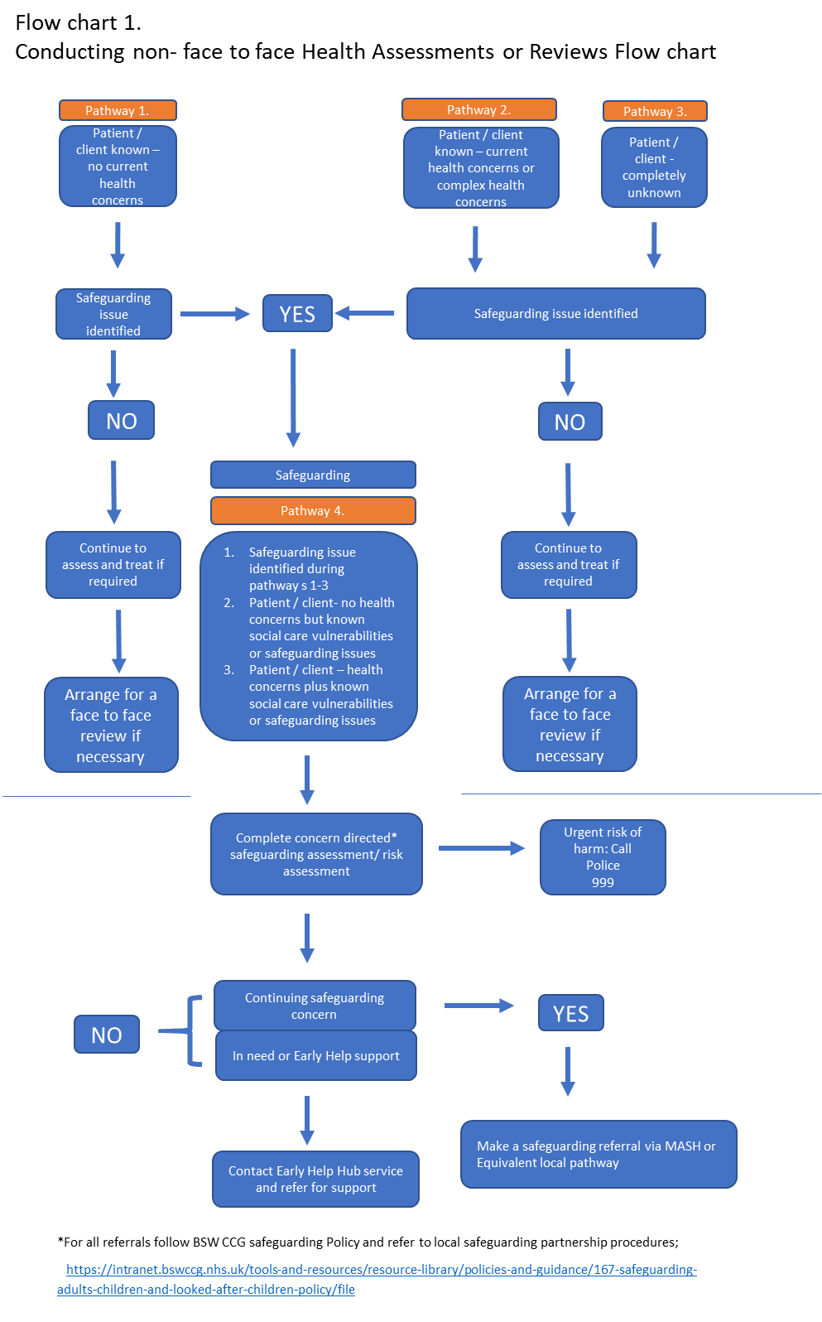

Author:
Rob Mills Designated Nurse safeguarding Swindon Locality BSW CCG draft4 11/6/20
Disclaimer:
This guidance is still in draft while being ratified within BSWCCG and should be read with that in mind. Those using this guidance are reminded of their professional codes of conduct in relation to their clinical decisions including safeguarding. This guidance is intended to assist health professionals in that endeavour.

This guidance will be reviewed within 6 months following feedback from health professionals who have been using it.
If you have any feedback or suggestions on ways to improve then e-mail them to Robert.mills1@nhs.net

