One Swindon Partnership

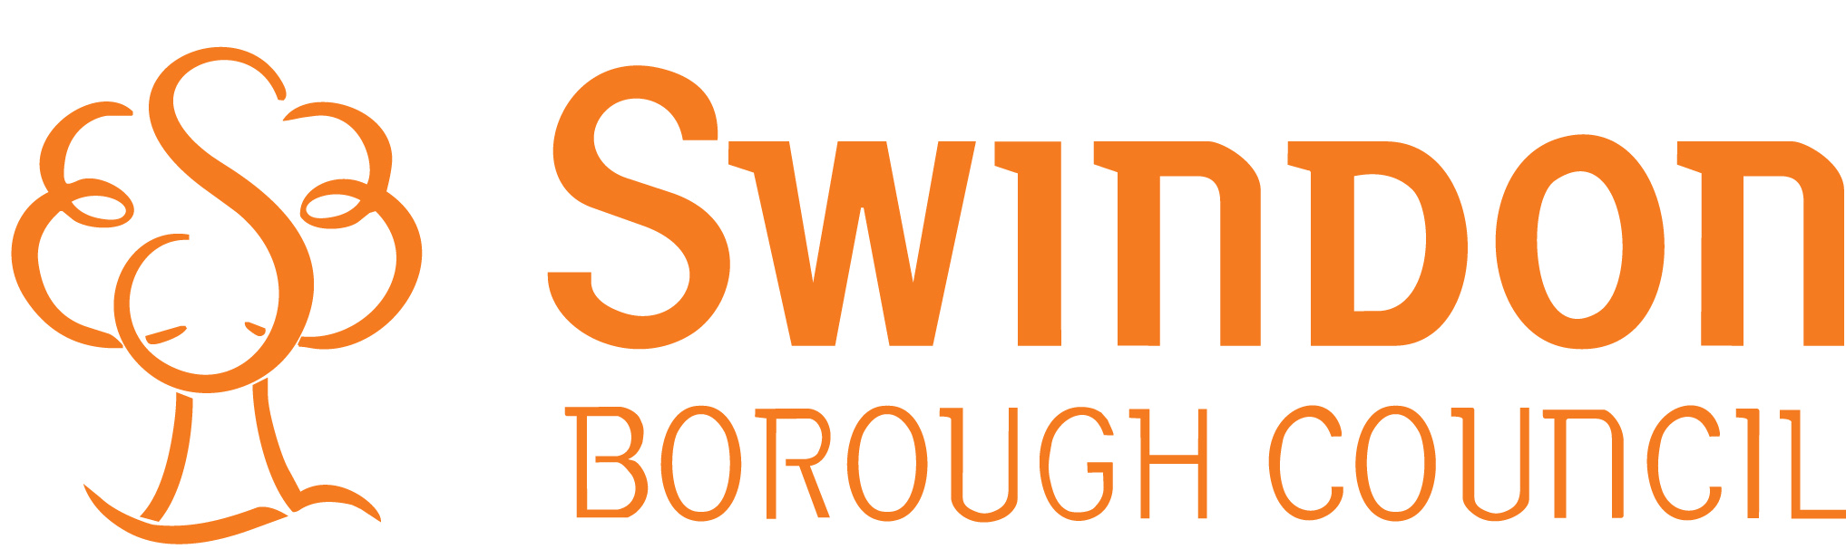 Revised 24 August 2015

Children, Families and Community Health

How information about you will be used

Why organisations keep and share information about you and your child

Swindon Borough Council provides a range of community health, social care and early help services such as the Youth Engagement Service and Education Support Services. This in an integrated children’s service and is called Children, Families and Community Health. It also works with families as part of the Troubled Families national initiative.

This Service and Swindon’s Children Centres hold information on paper and on an electronic database about your family, if you are in receipt of a service. Once your information is on the database, other professionals within Swindon Borough Council Children Services will be able to see which services you are accessing and case information. Staff need this information so they can give the best advice possible and offer support.

Individual case information will not be shared outside of the Children’s Service unless consent has been given, or there is a risk of significant harm to a person. General demographic data such as; name, address, date of birth, ethnic group and special educational needs will be shared between organisations that provide public sector services in Swindon and form together as the One Swindon Partnership. The One Swindon Partnership includes a range of health care providers and local council services.

Further information about how organisations use your information can be found at the following website in the document “Contact details and data sharing between organisations”.
http://www.swindon.gov.uk/cd/cd-dataprotection/Pages/cd-dataprotection.aspx
If you are concerned in relation to data sharing and would like to opt out of allowing us to share information, you can contact us by:

Email: datamanager@swindon.gov.uk

or

Letter: Data Manager,
Children Services Information and Performance Team
Swindon Borough Council
Civic Offices
Euclid Street
SN1 2JH

