Missing Aide Memoire

Missing: “Anyone whose whereabouts cannot be established will be considered as missing until located and their well-being or otherwise confirmed.”
College of Policing Authorised Professional Practice 2017

Missing question set:

  - When and where were they last seen? Where?
  - Is the person a cared for or a looked other than by their family? In what way?
  - What is the specific concern that has caused you to call the Police?
  - What has been done so far to trace this individual?
  - Is this significantly out of character (has there been a recent change in the person’s behaviour)?
  - Do they need urgent medical attention or essential medication that is not likely to be available to them?
  - Are they likely to be subjected to any other crime?
  - Are they likely to be the victim of any other form of abuse?
  - If under 18, are they currently at risk of child abuse including child sexual exploitation?
  - Are they likely to attempt suicide?
  - Do they pose a danger to other people?
  - Is there any other information relevant to their absence?
  - Is the person detainable under any mental health legislation?
  - Is the person vulnerable due to other factors?
  - Is the person particularly at risk of harm due to physical disability, frailty, or memory loss?
  - Does the person lack the ability to interact safely with others in an unknown environment (mental illness, learning disability, and/or sensory impairment)?
  - Has the person been involved in any violent, homophobic, or racist incident immediately prior to their disappearance?
  - Any child safeguarding concerns (subject to child protection plan, known to social care / PVP, and/or specific PNC warning flag triggered)?
  - Is the person suffering from a drug and / or alcohol dependency?
  - Any social concerns (family / relationship / employment / financial / school / college)?
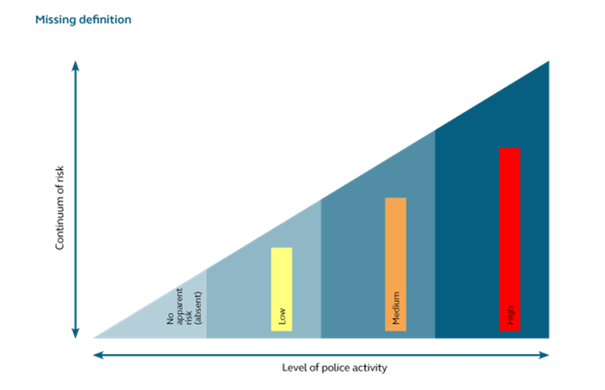
No apparent risk (previously absent)
There is no apparent risk of harm to either the subject or the public. | Actions to locate the subject and/or gather further information should be agreed with the informant and a latest review time set to reassess the risk.
Low risk
The risk of harm to the subject or the public is assessed as possible but minimal. | Proportionate enquiries should be carried out to ensure that the individual has not come to harm.
Medium risk
The risk of harm to the subject or the public is assessed as likely but not serious. | This category requires an active and measured response by the police and other agencies in order to trace the missing person and support the person reporting.
High risk
The risk of serious harm to the subject or the public is assessed as very likely.  Serious harm is defined as: ‘A risk which is life threatening and/or traumatic, and from which recovery, whether physical or psychological, can be expected to be difficult or impossible.’  Where the risk cannot be accurately assessed without active investigation, appropriate lines of enquiry should be set to gather the required information to inform the risk assessment.  (Home Office 2002 and Offender Assessment System 2006) | This category almost always requires the immediate deployment of police resources – action may be delayed in exceptional circumstances, such as searching water or forested areas during hours of darkness. A member of the senior management team must be involved in the examination of initial lines of enquiry and approval of appropriate staffing levels. Such cases should lead to the appointment of an investigating officer (IO) and possibly an SIO, and a police search adviser (PolSA).  There should be a press/media strategy and/or close contact with outside agencies. Family support should be put in place where appropriate. The MPB should be notified of the case without undue delay. Children’s services must also be notified immediately if the person is under 18.

