Swindon Safeguarding Partnership / Wiltshire Police (Youth and Early Intervention)
Videos for Virtual Forum – Support Services in Themes

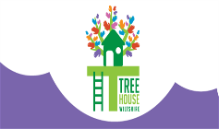
ACEs/PACEs/Trauma

Wiltshire Treehouse – A bereavement support service for children and young people in Swindon and Wiltshire.

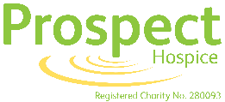
Project Hospice – Prospect Hospice aims to provide the best possible end-of-life care for everyone, whenever and wherever they need it. Our approach is compassionate, respectful and personalised to everyone who seeks it.
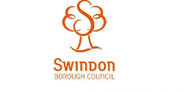
Swindon Family Service (Swindon Borough Council) – The Family Service will work with vulnerable children, young people and their families from pre-birth to 18 years of age. The service receives its referrals from the Multi Agency Safeguarding Hub (MASH), the locality Social Work teams, Assessment and Children Protection team and health visitors.
Swindon Carers – Swindon Carers Centre is a charitable organisation, which is part of the Carers Trust Network, established to provide help and support to the 21,000 unpaid carers in Swindon.
Therapeutic Service (Swindon Borough Council) – The service receives its referrals from the Multi Agency Safeguarding Hub (MASH), the locality Social Work teams and health visitors.

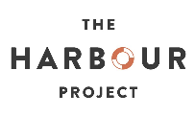
Youth Violence / Drugs / Exploitation

The Harbour Project – Welcoming and supporting refugees and asylum seekers in Swindon
Youth Engagement Work (Swindon Borough Council) – A team of skilled professionals who work with vulnerable and difficult to engage young people using a variety of methods including face-to-face sessions, groups and social media.
Leaders Unlocked (Youth Commission on Police and Crime) - The Commission allows young people aged 14-25 years to work in partnership with their Police and Crime Commissioners and police forces to tackle urgent issues such as reducing youth offending, relationships with the police, and support for young victims and witnesses.

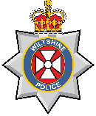
Early Help / Early Intervention

SWIFT (Swindon and Wiltshire Interventions for Families to Thrive – Wiltshire Police) – Wiltshire Police now offer a new targeted intervention programme for children/young people (SWIFT) which builds on the previous Early Intervention Project.
Mini Police (Wiltshire Police) – The Mini Police programme supports the principles of preventing crime, reducing Anti-Social Behaviour (ASB) and reassuring communities, working with partner agencies, raising awareness of online safety and digital crime as well as helping to safeguard vulnerable young people in local communities.

Work Experience (Wiltshire Police) – The scheme is designed to give Year 10 students across Wiltshire and Swindon a taste of what it's like to work for the police service.
School Lessons (Wiltshire Police) – The Youth and Early Intervention Team within Wiltshire Police provide training to upskill Police Officers, new and already established PCSOs and Police Staff on the offer for Primary and Secondary schools.
Junior Good Citizen (Wiltshire Police) – The Junior Good Citizen scheme is designed to engage young people across Swindon and Wiltshire in a fun learning environment and equip them with life skills as they make their transition from primary to secondary education.
Mentoring Circles (Wiltshire Police and Job Centre Plus) – Supporting young people to move closer to the Job Market; promoting resilience and highlighting how to create a high standard job application if applying for roles within the Police.
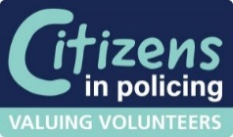
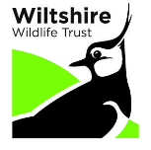
Volunteer Police Cadets (Wiltshire Police) – Cadets volunteer at community events and initiatives alongside Wiltshire Police officers, PCSOs and members of the Special Constabulary. Cadets have supported several high-profile events including Solstice, WOMAD, Swindon Pride and the Emergency Services Show to date. Cadets are between 13-17 years old.

Wiltshire Wildlife Trust – WWT exists to protect the environment and encourage sustainable living for the benefit of both people and nature.
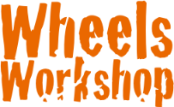
Wheels Workshop – Wheels Workshop is an engagement, enrichment and intervention program for teenagers aged between 13 and 17 in and around Swindon, focusing on mechanics and motoring.

Premier League Kicks (Swindon Town FC) – PL Kicks started in 2006 and has a long history of using the power of football and the value of sports participation to help youngsters in some of the most high-need areas.

Iprovefit Ltd – A credible, growing provider of establishing trusting relationships, breaking down barriers to learning and personal growth through positive role-modelling, strengthening and influencing confident values around oneself and reaching those significant aspirations.
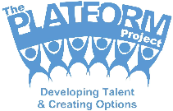
The Platform Project – The Platform Project is a not-for-profit youth development scheme that helps young people develop confidence and employability skills through a range of different enterprise activities.
Wiltshire Community Foundation – An independent charity that connects people who care with causes that matter to build a vibrant and strong voluntary and community sector enabling more people across Wiltshire and Swindon to thrive.
Swindon Parenting Hub (Swindon Borough Council) – Swindon Parenting Hub provides support and advice to families with children aged 0 - 19 years throughout the borough.
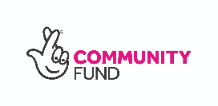

National Lottery Community Funding – The National Lottery Community Fund gives grants to organisations in the UK to help improve their communities.
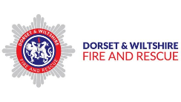
Dorset & Wiltshire Fire and Rescue Service – DWFRS have several schemes aimed specifically at helping young people learn and aspire, such as Fire Cadets, Firesetters education, DWISE and being ‘fire-fit’.
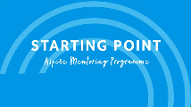

Starting Point – Providing mentoring and creating opportunities for young people aged 11-25.

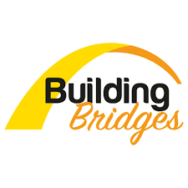
Mental Health

Building Bridges – Helping people overcome their barriers to employment or education across Swindon and Wiltshire.

Kooth Swindon – An online mental wellbeing community. Access free, safe and anonymous support.
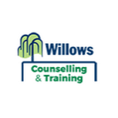

Willows Counselling & Training – Willows is a counselling service, which upholds the unique value of each and every individual.

Ipsum Swindon – A Mental Health and Wellbeing Centre supporting Swindon and the surrounding area.

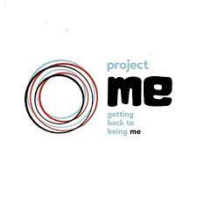
Swindon Trailblazer - Project Me (Barnardos) – Swindon Trailblazer is an early help mental health service for children and young people between the ages of 5-19 years within Swindon.

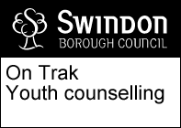
On Trak - Youth Counselling Service (Swindon Borough Council) – On Trak is a counselling service for young people who, at the time of referral, are experiencing mental health problems that are likely to respond positively to 'talk-based' therapies.
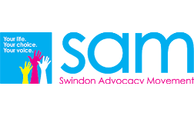

Swindon Advocacy Movement (SAM) – SAM's mission is sounding a clear and consistent voice for the rights of the people with care and support needs.
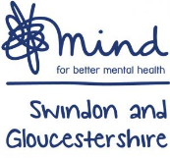

Mind (Swindon and Gloucestershire) – Mind use a solution focused approach which supports people to identify their own strengths and skills to aid recovery.

Healthwatch Swindon – Healthwatch’s sole purpose is to understand the needs, experiences and concerns of people who use health and social care services and to speak out on their behalf.

Support for Disabilities
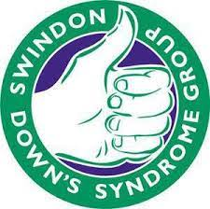
Swindon Down Syndrome Group – A parent-led charity supporting people with Down's Syndrome, their families, carers and all those with an interest in Down's Syndrome in Swindon.

